# Air quality sensor

# Setting the scene

In this tutorial you are going to build a device to measure air quality. You will use the MKR 1000 board, MKR connector carrier and Grove Air Quality sensor. The connector carrier can be used to connect any of the Grove sensors.

# Success criteria

* Understand what a ***forever*** loop does
* Understand what the air quality sensor measures
* Understand that if code is only to be executed if a condition is true then an ‘if then else’ statement can be used
* Be able to report readings from a sensor to the Arduino IoT cloud

# Instructions

The first step is to assemble your device.

Plug the MKR 1000 into the MKR Connector Carrier. Be careful to ensure that you line up the pins correctly and don’t cause any of the pins to bend. You need to ensure that all of the pins on the MKR 1000 tie up with the equivalent labels on the connector carrier.

Then, plug in the Grove Air Quality sensor into port A0 on the connector carrier.

The Grove Air Quality sensor is an example of a shield. A shield is a modular circuit board that you can add to an Arduino to give it additional functionality.

# Pro-tip

The plug will only connect to the connector carrier one way around. If it doesn’t fit, don’t force it, you may have it the wrong way around.

Your device is now assembled and ready to be programmed.

Initially, you need to install the relevant libraries. A library is a set of pre-written routines which a program can use. The Air Quality libraries can be downloaded from: <https://github.com/Seeed-Studio/Grove_Air_quality_Sensor>

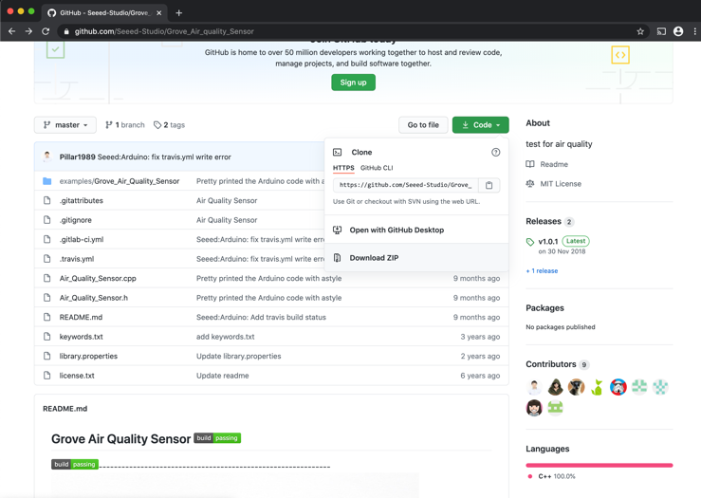

You should then click on ‘Code’ and download the zip file.

You now need to install the library into your IDE. Sign into Arduino cloud and go to the text editor. You should then click on ‘Libraries’.

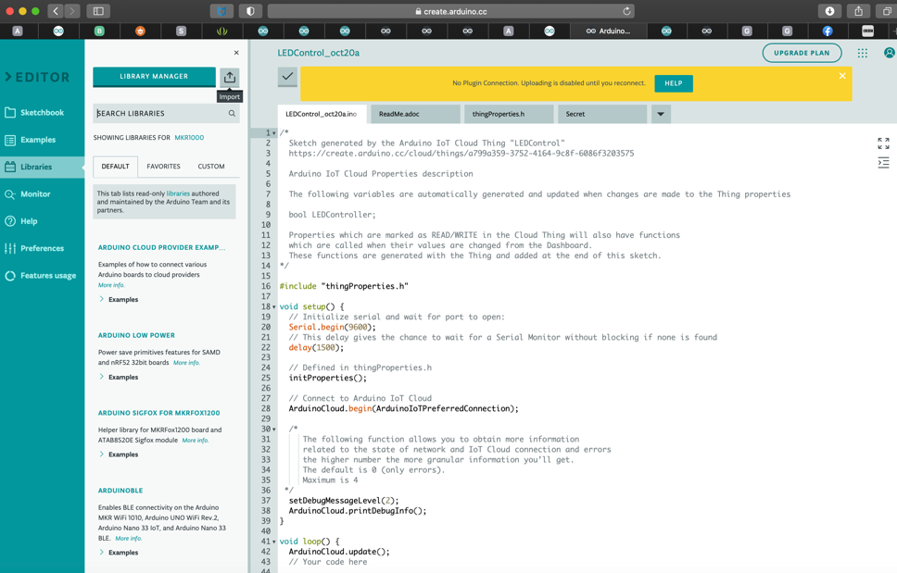

Once in the libraries menu you will see an option to import a library. Click on this button and then select your recently downloaded zip file.

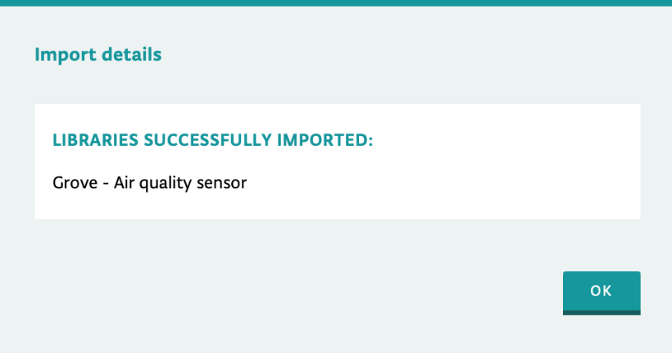

You will then receive a confirmation message to inform you whether the library has been successfully imported.

You are now going to test your device using the example code that comes with the library.

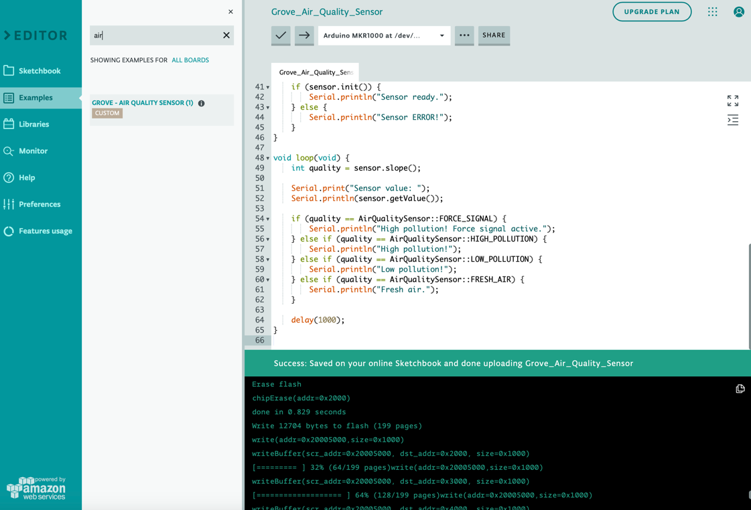

Click on ‘Examples’ and search for ‘air’. You will then see a sample file for the Air Quality Sensor. Click on this file and then upload it to your device.

Once you have successfully uploaded it to your device you should then select monitor from the left-hand menu. This will show you the readings that your device is currently taking. Please note that there may be a delay between uploading the sketch and the readings appearing.

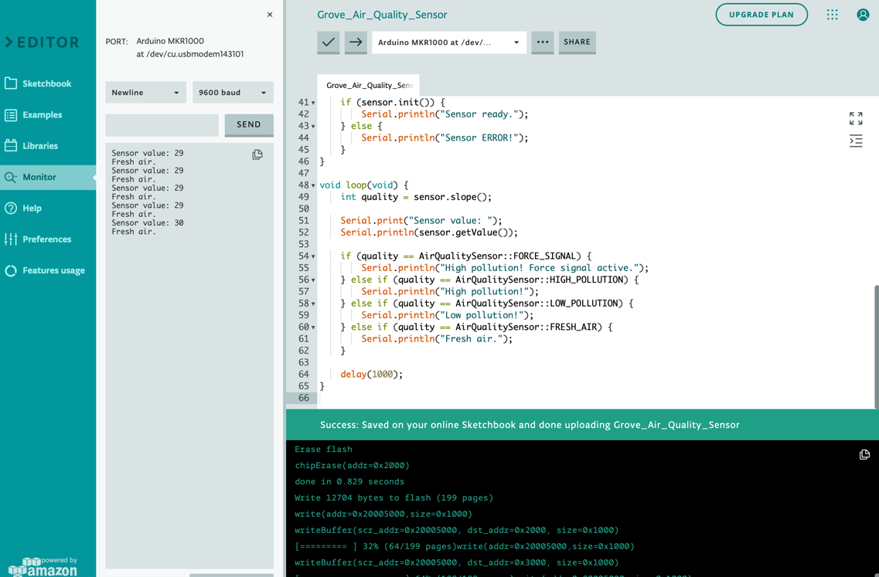

At this stage you now know whether or not your device is taking readings. Now we want to send these readings to the Arduino Cloud so that we can see a log of readings from throughout the day.

You should now return to the Arduino IoT Cloud and create a new thing.

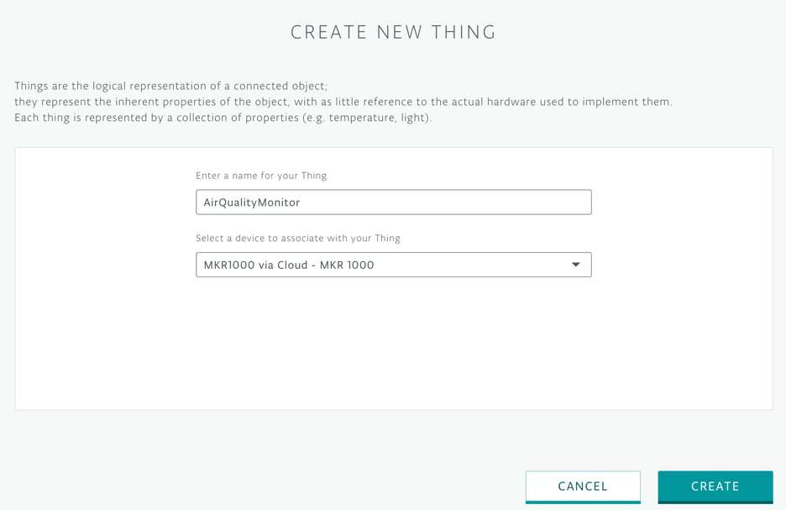

Name your thing with a descriptive name and choose the board that it will run on.

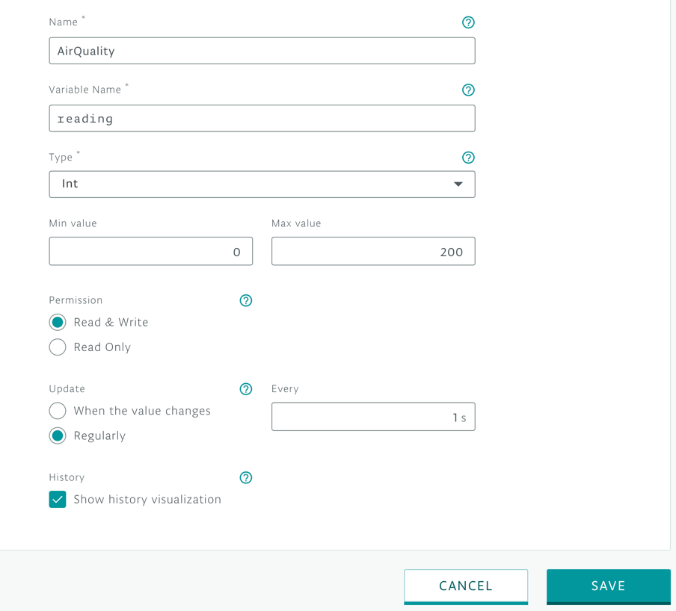

Once you have created your thing, you should create a new property. In the example above, the property has been named ‘AirQuality’ and the variable is named reading. The sensor will return a whole number, so it is important that the data type is set as int. Click on ‘Save’.

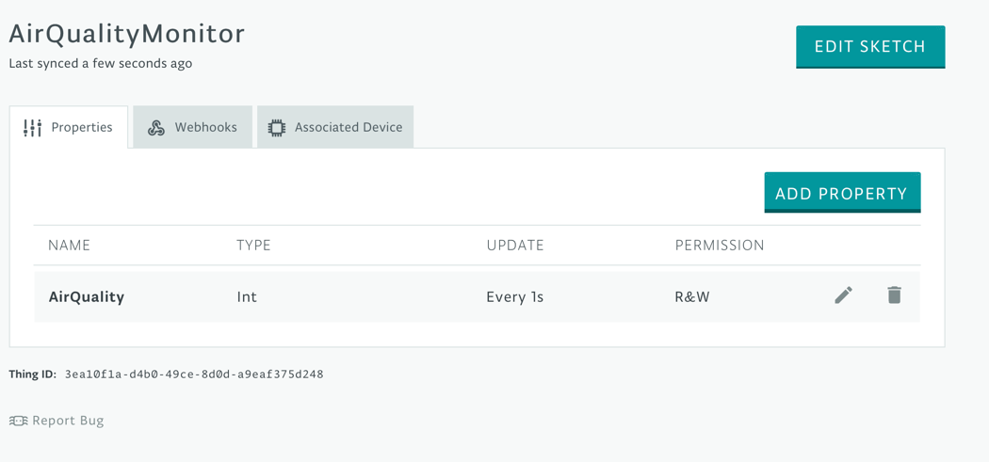

You should now select ‘Edit sketch’. This will take you to the basic code which has been automatically generated. You now need to write the sensor value back to the variable ‘reading’ so that it can be sent back to the IoT cloud.

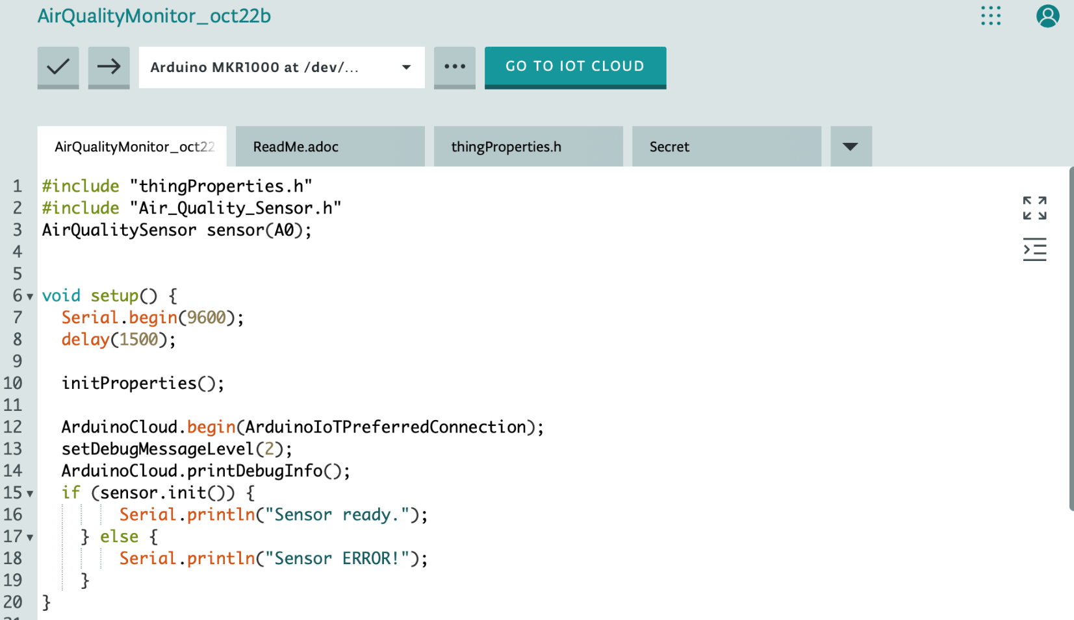

First, you should import the air quality sensor library using the code on line 2. You also need to say which port the sensor is plugged into which is defined on line 3. Inside the setup loop, you should add the various lines relating to the sensor. These have been taken from the example file.

This completes the setup loop. You now need to add the main loop which handles the readings. 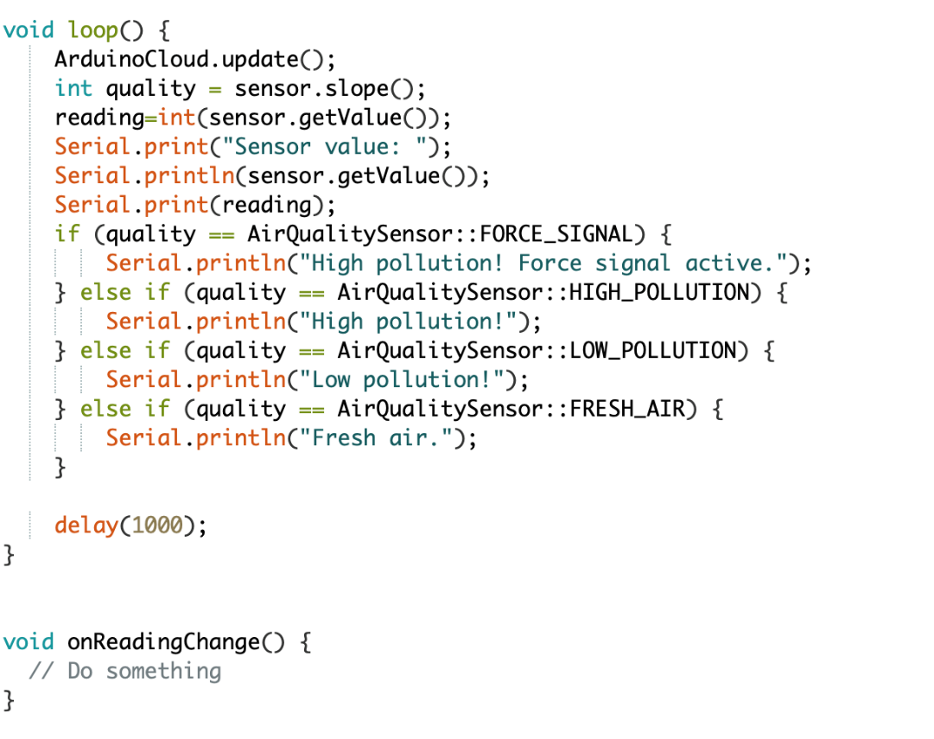

It’s important to state that the reading is an integer in order to ensure that the data is successfully transferred to the cloud. The if statement has been added from the example file, but this information isn’t added to the cloud. You can now upload your program to your device and check in the monitor tab that values are recorded successfully. The Serial.print lines are the commands which are outputting to the monitor.

It is now time to create your IoT dashboard. Click on ‘Return to IoT cloud’ and then ‘Dashboards’.

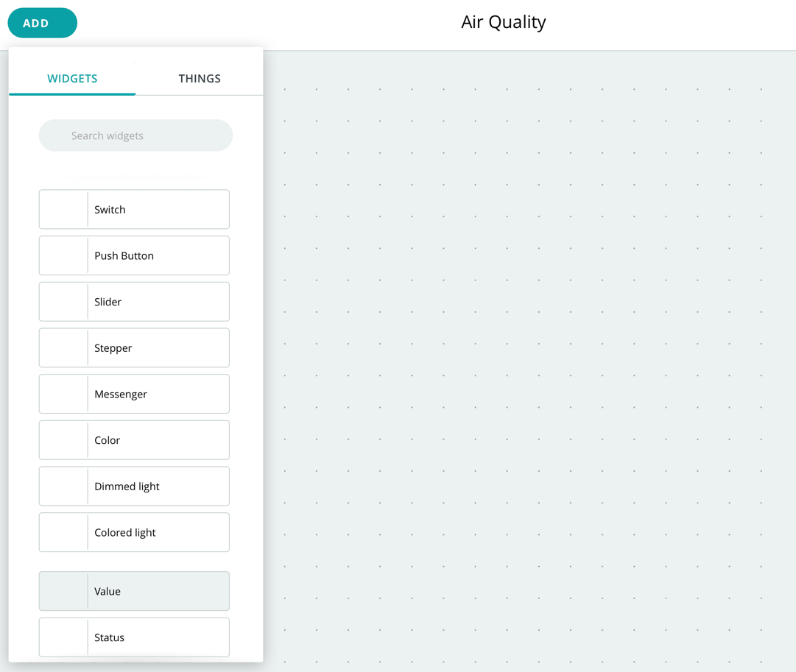

Create a new dashboard, give it a meaningful name and then add a value widget.

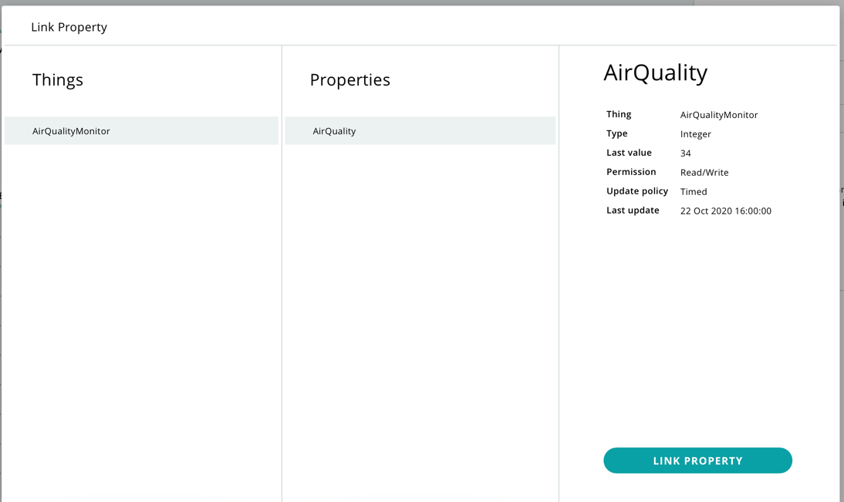

Give your widget a name and attach it to the property which you defined earlier. Click on ‘Link property’.

Repeat the same process for a chart widget. You will then see your data being displayed live.

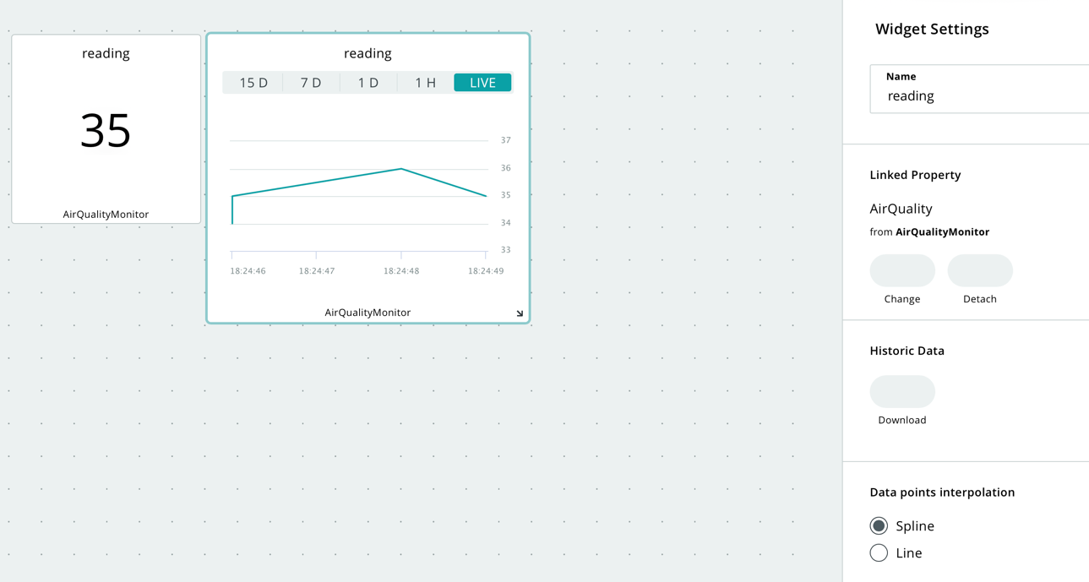

Once you have a set of data ready for analysis you could download all recorded data as a csv file by selecting ‘Download’. You can then either analyse it using a spreadsheet or a coded application.

# Testing

When you look at the dashboard you should be able to see live readings being taken. Try blowing into the sensor to see the impact that it has on the readings. All of the readings will be recorded onto a csv file. Open the file by clicking on the button under historic data. If your device has been built and programmed correctly, you should see all of the readings that it has taken.